Disk Check Valve
Operation Manual
1. Scope
This manual covers disk check valves with flange and wafer-style connections, in nominal diameters DN15 mm to DN1,000 mm (1/2" to 4") and nominal pressures PN1.6 MPa to PN10 MPa (ANSI Class 150 to 600).
2. Purpose
2.1 This valve is used in pipelines or equipment to prevent medium backflow.
2.2 Valve body material shall be selected based on the medium:
2.2.1 Carbon steel valves — suitable for water, steam, and oil media.
2.2.2 Stainless steel valves — suitable for corrosive media.
2.3 Applicable temperature ranges:
2.3.1 Standard carbon steel valves: -29 C to +425 C
2.3.2 Alloy steel valves: -29 C to +550 C
2.3.3 Stainless steel valves: -196 C to +200 C
3. Structure
3.1 The basic structure of the disk check valve is shown in Figure 1.
4. Operating Principle
The disk check valve opens automatically when the forward pressure of the medium overcomes the spring closing torque. The spring elastic torque returns the disk to the closed position, and the reverse pressure of the medium creates the sealing contact pressure to achieve a tight seal.
5. Storage, Maintenance, Installation, and Use
5.1 Valves shall be stored indoors in a dry and ventilated area; both pipeline openings shall be sealed.
5.2 Valves stored long-term shall be inspected periodically; remove debris. Pay special attention to keeping the sealing faces clean to prevent damage.
5.3 Before installation, verify that the valve markings match the service requirements.
5.4 Before installation, inspect the valve bore and sealing faces; if any contaminants are present, wipe clean with a soft cloth.
5.5 Before installation, ensure the flow-direction arrow on the valve body aligns with the direction of medium flow.
5.6 Depending on pipeline configuration, this disk check valve can be installed either vertically or horizontally.
5.7 During operation, monitor the valve for any abnormal sounds or vibration. To prevent water hammer effects in the pipeline, pay close attention to medium pressure fluctuations.
6. Possible Faults, Causes, and Resolutions -- See Table 1
Table 1 Possible Faults, Causes, and Resolutions
Possible Fault | Cause | Resolution
Disc fails to open / close | 1. Rocker arm and pin fit too tight or obstructed  2. Foreign matter lodged inside valve | 1. Inspect and correct the fit; remove obstructions  2. Clear foreign matter from valve interior
Valve noisy / vibrating | 1. Valve installed too close to pump  2. Pipeline pressure fluctuates | 1. Re-install at appropriate distance from pump  2. Eliminate pressure fluctuations
7. Warranty
The manufacturer provides warranty for valves placed into service for up to one (1) year from start of use, but no longer than eighteen (18) months from date of shipment. During the warranty period, any failures attributable to product quality will be repaired or have parts replaced at no charge.
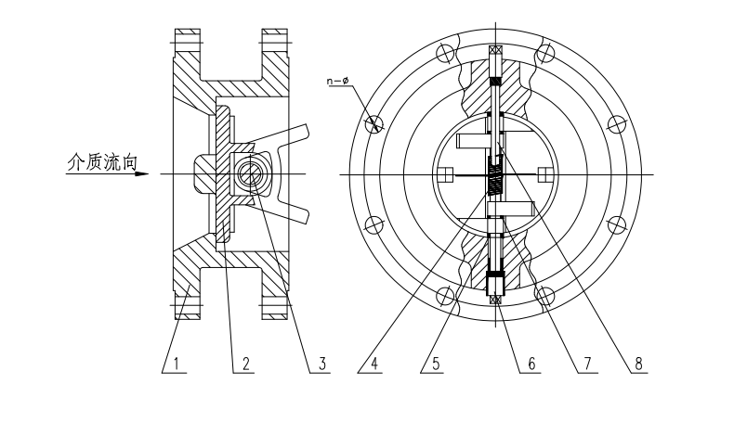
Figure 1 Disk Check Valve Structure
Flanged Disk Check Valve


WEIZIDOM GROUP
www.wsdvalves.com
South City, Longhu Town, Xinzheng City,
Zhengzhou City, Henan Province, China

